A000-Afr-Gabon-Fang Reliquary Male Bust-Early 20th c

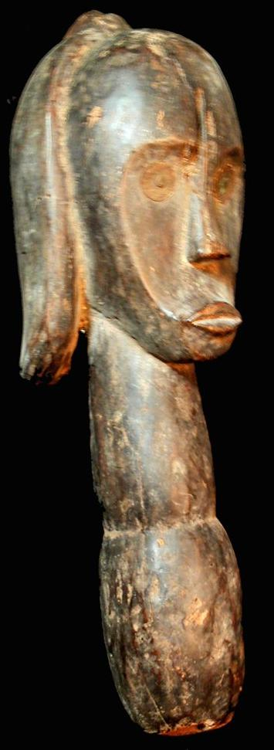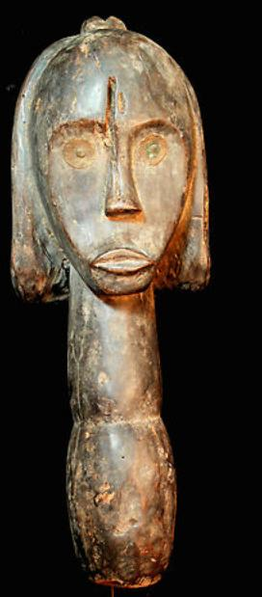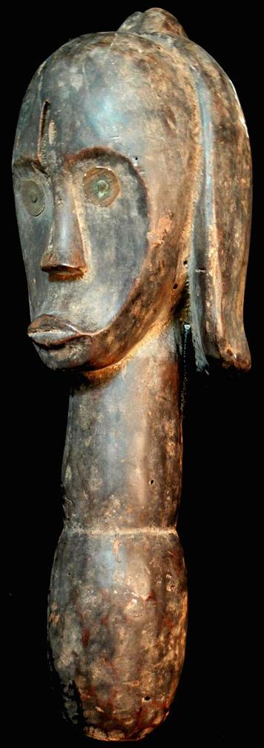

Figs. 1-3. Afr-Gabon-Fang Reliquary Male Bust-Early 20th c

Case No.:

**Accession No.**

**Formal Label:** Afr-Gabon-Fang Reliquary Male Bust-Early 20th c

**Display Description:**

**LC Classification:**

**Date or Time Horizon:**

**Geographical Area:**

**Map:**

**GPS coordinates:**

**Cultural Affiliation:**

**Media: wood, brass**

**Dimensions: H** 16.535 in

**Weight:** 2.95 pounds

**Condition:**

**Provenance:**

**Discussion:**

**References:**

